Steps in Applying the Equity Lens Tool
Our aim is to provide a tool that is flexible, adaptable, and efficient, and that involves communities who are most affected by COVID-19 and the proposed decision in the process. We do not expect that a health department will have capacity for deep, time-intensive background research. However, we encourage health departments to follow these steps in conducting their assessment. This fillable pocket guide allows you to fill in responses the Equity Lens Assessment of Step 4. Please see the full tool document and appendices at www.bigcitieshealth.org/equitytool to for more detail on how to use this pocket guide, especially related to planning, community involvement, and communications -- all of which are important aspects of using this tool. 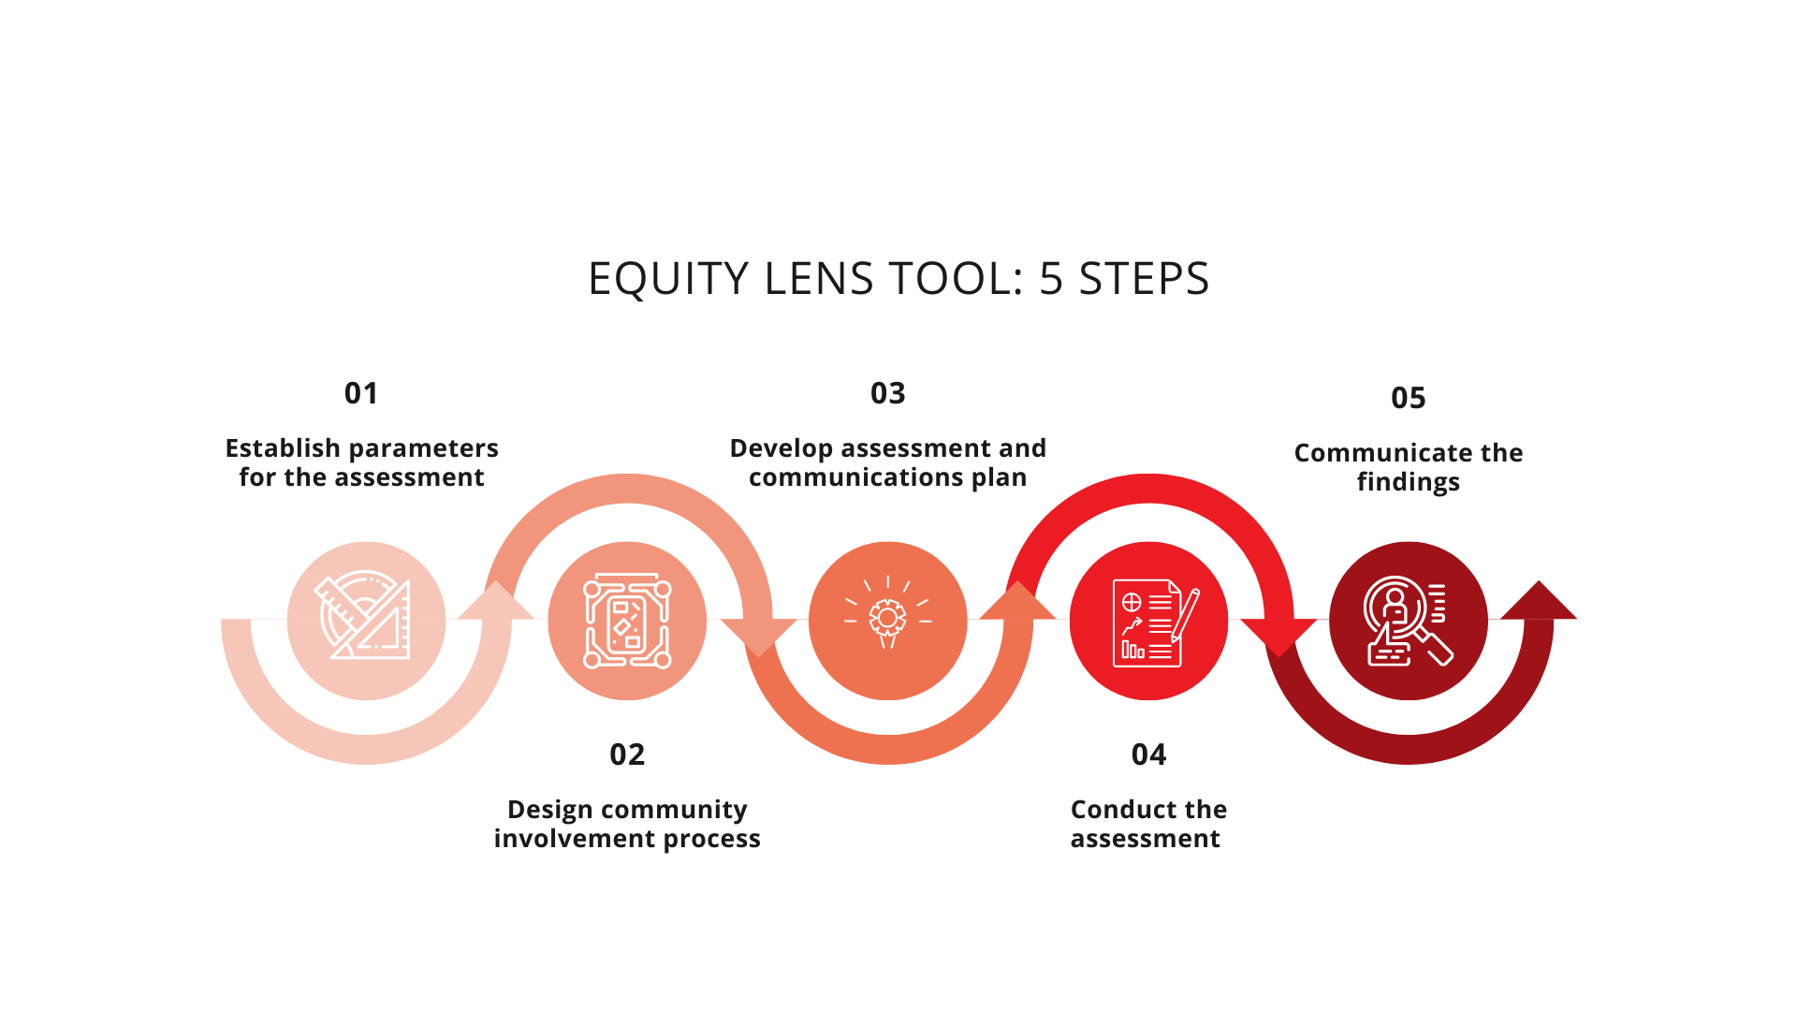
Step 4: Core and Detailed Questions of the Equity Lens Tool
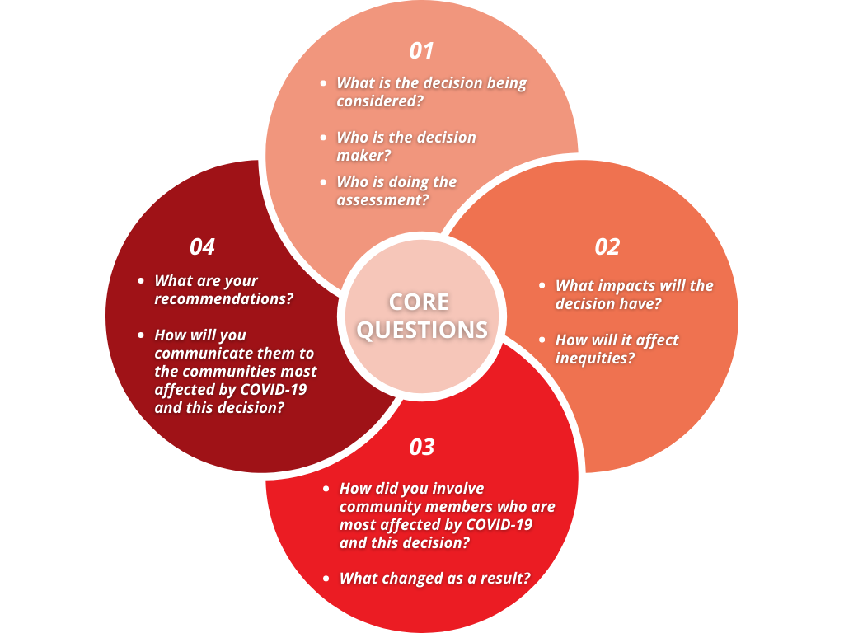
This graphic shows the core questions asked in the Equity Lens Assessment. The more detailed questions are then provided with fillable boxes to dig into these core questions further.

Equity Lens Tool Core & Detailed Questions
- What is the decision being considered, and who is the decision maker? Who is doing the assessment?
- What is the decision under consideration, and what is the scope (e.g., budget, policy, program, initiative)?

Click or tap here to enter text.
- Who is the decision maker? Who else is involved in decision making?

Click or tap here to enter text.
- Who is completing this assessment? Who needs to review it? When is it due?

Click or tap here to enter text.

- What impacts will the decision have? How will it affect inequities?
- What current inequities exist around this issue? How does structural racism, in particular, contribute to those inequities?

Click or tap here to enter text.
- Will any groups experience unintended impacts or greater burden, or be left out by this decision^{i}?

Click or tap here to enter text.
- Given the above, will the decision worsen or ignore existing disparities?

Click or tap here to enter text.
- Will any groups or communities disproportionately benefit from the decision? Are they the people who are facing inequities?

Click or tap here to enter text.
- Describe the potential unintended impacts on social, economic, and environmental factors affecting health^{ii}.

Click or tap here to enter text.
- What data are you drawing on to come to this conclusion? Consider quantitative and qualitative data alike.

Click or tap here to enter text.

- How did you involve community members who are most affected by COVID-19 and by this potential decision in the assessment? What changed as a result?
- Which community members — from the groups most affected by COVID-19 and this decision — have been informed, involved, and represented in the decision-making process? If none, explain why and the plan for input.

Click or tap here to enter text.

- Consider: race/ethnicity, gender, sexuality, socioeconomic status, education, occupation, disability, immigration status, religious/faith community, health insurance status, housing status, criminal legal system involvement, age, and neighborhood.
- Consider: economic stability; criminal justice; environmental quality; housing availability and affordability; access to food, education, and healthcare; social cohesion; civic participation; and/or other factors.

- Describe how you involved the community in this assessment, including whom you worked with and what you did to involve them. Describe how you addressed barriers related to language, literacy, transportation, or compensation.

Click or tap here to enter text.
- What did you learn from your engagement? What was new, and what was confirmed?

Click or tap here to enter text.
- What are you proposing to change in your decision in response to what you learned from community involvement?

Click or tap here to enter text.

- What recommendations will you make? How will you communicate the recommendations to communities who are most affected by COVID-19 and the decision?
- What needs to change in the proposed decision to ensure equity? What recommendations do you propose?

Click or tap here to enter text.
- Who is responsible for these changes?

Click or tap here to enter text.
- What competing interests, external to the community and the health department, may influence the ability of the recommendations to be taken (especially if cited by the community)?

Click or tap here to enter text.
- How will the assessment findings and final decision be communicated back to those most affected by the decision?

Click or tap here to enter text.
- Can any part of these findings be incorporated into other related processes to advance equity?

Click or tap here to enter text.

Suggested Citation
Ensuring Equity in COVID-19 Planning, Response, and Recovery Decision Making: An Equity Lens Tool for Health Departments Pocket Guide. Human Impact Partners and Big Cities Health Coalition, December 2020.
Contact Information
Lili Farhang, Co-Director, Human Impact Partners, lili@humanimpact.org
Gabrielle Nichols, Program Associate, Big Cities Health Coalition, nichols@bigicitieshealth.org

